# JS

function multiply(a, b) {b = (typeof b !== ‘undefined’)? b : 1 return a * b}

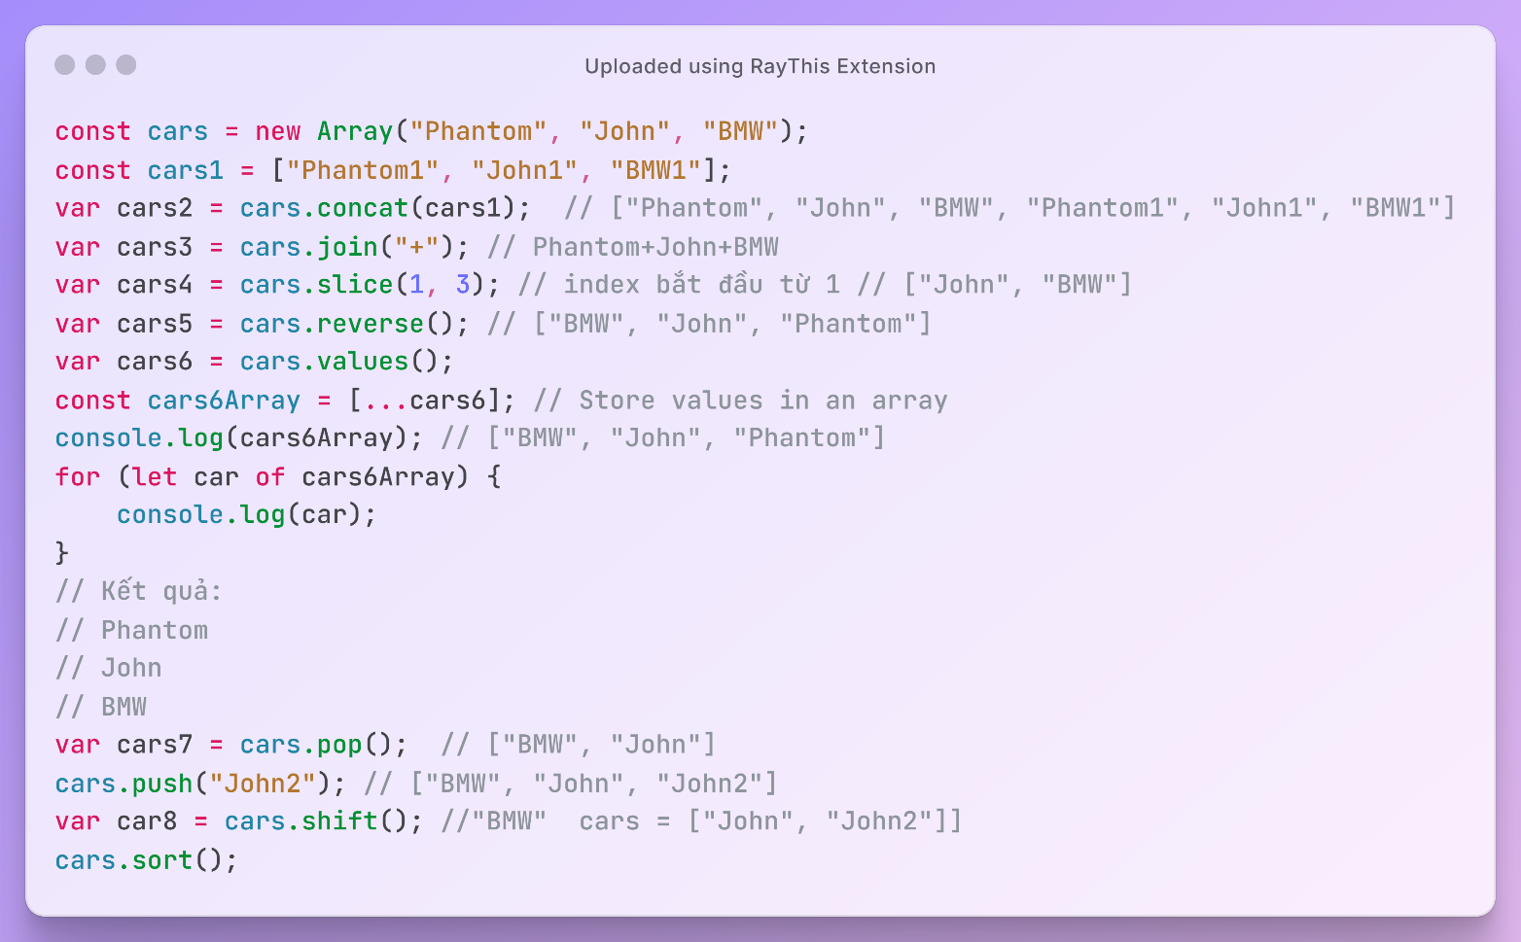

# A screenshot of a computer program AI-generated content may be incorrect.DOM



